# LSC Learning Management System

**Project Documentation Submitted**

**To the Faculty of School of**

**Computer Science and Information Technology**

**Of**

**Asia Pacific College**

**In Partial Fulfillment of the Requirements for the subject**

**Applied Projects 2 or Software Development**

**Gardon, Jana Marie G.  
Heramia, Johanna Marisse C.  
Tadeo, Jose Lorenzo G.**

Table of Contents

[LSC Learning Management System 1](#_Toc469575160)

[Executive Summary 7](#_Toc469575161)

[List of Figures, List of Tables, List of Notations 7](#_Toc469575162)

[I. Introduction 7](#_Toc469575163)

[**a.** **Project Context** 7](#_Toc469575164)

[**b.** **Purpose and Description** 7](#_Toc469575165)

[**c.** **Objectives** 9](#_Toc469575166)

[**d.** **Scope and Limitations** 9](#_Toc469575167)

[II. Review of Related Literature/Systems 10](#_Toc469575168)

[III. Technical Background 11](#_Toc469575169)

[IV. Methodology, Results and Discussion 11](#_Toc469575170)

[**a.** **Requirement Analysis** 11](#_Toc469575171)

[**b.** **Requirements Documentation** 11](#_Toc469575172)

[**c.** **Design of Software, Systems, Product, and/or Processes** 12](#_Toc469575173)

[**1.** **Frontend** 12](#_Toc469575174)

[**A.** **Main Page** 12](#_Toc469575175)

[**B.** **Login Page** 12](#_Toc469575176)

[**2.** **Backend** 13](#_Toc469575177)

[**A.** **Login Page** 13](#_Toc469575178)

[**A.** **Main Page** 13](#_Toc469575179)

[**3.** **PhpMyAdmin Database** 14](#_Toc469575180)

[**d.** **Development and Testing, where applicable** 15](#_Toc469575181)

[**e.** **Description of the Prototype, where applicable** 15](#_Toc469575182)

[**f.** **Implementation Plan (Infrastructure/Deployment) where needed** 15](#_Toc469575183)

[**g.** **Implementation Results, where applicable** 15](#_Toc469575184)

[**h.** **Conceptual design** 16](#_Toc469575185)

[V. Conclusions and Recommendations 16](#_Toc469575186)

[VI. Appendices 17](#_Toc469575187)

[**a.** **Relevant Source Code** 17](#_Toc469575188)

[**b.** **Evaluation Tool or Test Documents** 18](#_Toc469575189)

[**c.** **Sample input/output/Reports** 18](#_Toc469575190)

[**1.** **Event Table – Student** 18](#_Toc469575191)

[**2.** **Event Table – Instructor** 18](#_Toc469575192)

[**3.** **Event Table – Admin** 19](#_Toc469575193)

[**4.** **Use Case Full Description – Student** 19](#_Toc469575194)

[**5.** **Use Case Full Description – Instructor** 22](#_Toc469575195)

[**6.** **Use Case Full Description – Admin** 23](#_Toc469575196)

[**7.** **Use Case Diagram – Student** 24](#_Toc469575197)

[**8.** **Use Case Diagram – Employee** 24](#_Toc469575198)

[**9.** **Activity Diagram – Student** 25](#_Toc469575199)

[**10.**  **Activity Diagram – Employee** 28](#_Toc469575200)

[**11.**  **Object Diagram** 30](#_Toc469575201)

[**12.** **Class Diagram** 31](#_Toc469575202)

[**13.** **Communication Diagram** 32](#_Toc469575203)

[33](#_Toc469575204)

[**14.**  **State Machine Diagram – Student** 33](#_Toc469575205)

[**15.** **State Machine Diagram – Employee** 33](#_Toc469575206)

[**16.** **Timing Diagram – Student** 33](#_Toc469575207)

[**17.** **Timing Diagram – Instructor** 35](#_Toc469575208)

[**18.** **Timing Diagram – Admin** 35](#_Toc469575209)

[**19.**  **Package Diagram** 36](#_Toc469575210)

[**20.** **Component Diagram** 36](#_Toc469575211)

[**21.** **Deployment Diagram** 37](#_Toc469575212)

[**22.** **Sequence Diagram** 38](#_Toc469575213)

[**23.** **Composite Diagram** 39](#_Toc469575214)

[**24.**  **Interaction Diagram** 40](#_Toc469575215)

[**25.** **Context Flow Diagram** 40](#_Toc469575216)

[**26.** **Data Flow Diagram – Level 0** 41](#_Toc469575217)

[41](#_Toc469575218)

[**27.** **Data Flow Diagram – Level 1 – Create Requirement** 42](#_Toc469575219)

[**28.** **Data Flow Diagram – Level 1 – Update Student Profile** 42](#_Toc469575220)

[**29.** **Entity Relationship Diagram** 43](#_Toc469575221)

[**30.**  **Data Dictionary**  44](#_Toc469575222)

[**31.**  **Gantt Chart** 47](#_Toc469575223)

[**32.**  **WBS** 48](#_Toc469575224)

[**33.**  **Activity List** 49](#_Toc469575225)

[**34.** **Project Vision and Scope** 50](#_Toc469575226)

[**Business Requirements** 50](#_Toc469575227)

[**Background** 50](#_Toc469575228)

[**Business Opportunity** 51](#_Toc469575229)

[**Business Objective and Success Criteria** 52](#_Toc469575230)

[**Customer or Market Needs** 52](#_Toc469575231)

[**Business Risks** 53](#_Toc469575232)

[**Vision of the Solution** 54](#_Toc469575233)

[**Vision Statement** 54](#_Toc469575234)

[**Major Features** 54](#_Toc469575235)

[**Assumptions and Dependencies** 54](#_Toc469575236)

[**Scope and Limitations** 55](#_Toc469575237)

[**Scope of Initial Release** 55](#_Toc469575238)

[**Scope of Subsequent Release** 56](#_Toc469575239)

[**Limitations and Exclusions** 56](#_Toc469575240)

[**Business Context** 56](#_Toc469575241)

[**Stakeholders Profiles** 57](#_Toc469575242)

[**Project Priorities** 58](#_Toc469575243)

[**Operating Environment** 58](#_Toc469575244)

[**35.** **Statement of Work** 59](#_Toc469575245)

[**Introduction/Background** 59](#_Toc469575246)

[**Scope of Work** 59](#_Toc469575247)

[**Period of Performance** 60](#_Toc469575248)

[**Place of Performance** 60](#_Toc469575249)

[**Work Requirements** 60](#_Toc469575250)

[**Schedule/Milestones** 61](#_Toc469575251)

[**Acceptance Criteria** 62](#_Toc469575252)

[**Other Requirements** 63](#_Toc469575253)

[**36.** **Software Requirement Specification** 63](#_Toc469575254)

[**Introduction** 63](#_Toc469575255)

[**Purpose** 63](#_Toc469575256)

[**Document Conventions** 63](#_Toc469575257)

[**Intended Audience and Reading Suggestions** 63](#_Toc469575258)

[**Scope** 64](#_Toc469575259)

[**References** 65](#_Toc469575260)

[**Overall Description** 65](#_Toc469575261)

[**Product Perspective** 65](#_Toc469575262)

[**Product Functions** 66](#_Toc469575263)

[**User Classes and Characteristics** 67](#_Toc469575264)

[**Operating Environment** 68](#_Toc469575265)

[**Design and Implementation Constraints** 68](#_Toc469575266)

[**User Documentation** 69](#_Toc469575267)

[**Assumptions and Dependencies** 69](#_Toc469575268)

[**External Interface Requirements** 70](#_Toc469575269)

[**User Interfaces** 70](#_Toc469575270)

[**Hardware Interfaces** 71](#_Toc469575271)

[**Software Interfaces** 72](#_Toc469575272)

[**Communications Interfaces** 72](#_Toc469575273)

[**System Features** 72](#_Toc469575274)

[**Creating Course** 72](#_Toc469575275)

[**Description and Priority** 72](#_Toc469575276)

[**Stimulus/Response Sequences** 72](#_Toc469575277)

[**Functional Requirements** 72](#_Toc469575278)

[**Adding Tasks** 73](#_Toc469575279)

[**Description and Priority** 73](#_Toc469575280)

[**Stimulus/Response Sequences** 73](#_Toc469575281)

[**Functional Requirements** 73](#_Toc469575282)

[**Making Announcement in Calendar** 73](#_Toc469575283)

[**Description and Priority** 73](#_Toc469575284)

[**Stimulus/Response Sequences** 73](#_Toc469575285)

[**Functional Requirements** 73](#_Toc469575286)

[**Listing Attendance** 74](#_Toc469575287)

[**Description and Priority** 74](#_Toc469575288)

[**Stimulus/Responses Sequences** 74](#_Toc469575289)

[**Functional Requirements** 74](#_Toc469575290)

[**Other Nonfunctional Requirements** 74](#_Toc469575291)

[**Performance Requirements** 74](#_Toc469575292)

[**Safety Requirements** 75](#_Toc469575293)

[**Security Requirements** 75](#_Toc469575294)

[**Software Quality Attributes** 75](#_Toc469575295)

[**Security** 75](#_Toc469575296)

[**Reliability** 76](#_Toc469575297)

[**Scalability** 76](#_Toc469575298)

[**Availability** 76](#_Toc469575299)

[**Responsiveness** 76](#_Toc469575300)

[**Business Rules** 76](#_Toc469575301)

[**Other Requirements** 77](#_Toc469575302)

[**Appendix A: Glossary** 77](#_Toc469575303)

[**Appendix B: Analysis Models** 77](#_Toc469575304)

[**37.** **Change Management Plan** 78](#_Toc469575305)

[**Introduction** 78](#_Toc469575306)

[**Change Management Approach** 78](#_Toc469575307)

[**Definitions of Change** 79](#_Toc469575308)

[**Change Control Board** 80](#_Toc469575309)

[**Roles and Responsibilities** 80](#_Toc469575310)

[**Change Control Process** 81](#_Toc469575311)

[**38.** **Quality Plan** 82](#_Toc469575312)

[**Introduction** 82](#_Toc469575313)

[**Project Contractual Information** 82](#_Toc469575314)

[**Scope of Work and Quality Objectives** 83](#_Toc469575315)

[**Project Organization** 84](#_Toc469575316)

[**Project Duration and Scheduling** 84](#_Toc469575317)

[**Deliverables** 85](#_Toc469575318)

[**Review of Quality Plan** 85](#_Toc469575319)

[**Document and Record Control** 85](#_Toc469575320)

[**Document Procedures** 85](#_Toc469575321)

[**d.** **Users Guide** 87](#_Toc469575322)

[**e.** **Process/Data/Information Flow** 87](#_Toc469575323)

[**f.** **Test Results** 88](#_Toc469575324)

[**g.** **Sample Generated Outputs** 88](#_Toc469575325)

[**h.** **Pictures showcasing the data gathering, investigation done** 88](#_Toc469575326)

[**i.** **One-Page Curriculum** 89](#_Toc469575327)

# Executive Summary

The LSC Learning Management System is for the students and for the management of LSC. This system will be able help the student to track or review their performance based on the results of their completed tasks. Based on the student’s analysis, they will be able to know whether they need more improvement in their performance in class. Also, student can be notified easily if there are announcement(s) from their respective tutors in their classes. On the management side, the system can help them through management of the student's courses, tasks and attendance. Under a course that is created by the tutor, specific tasks can be created, updated or deleted.

# List of Figures, List of Tables, List of Notations

# Introduction

## **Project Context**

The LSC Learning Management System allow admin, instructors and students to make announcements, submit course assignments, monitor class progress, share educational material, and manage LSC faculty and students. The previous system of LSC was all done manually, taking up the time of both faculty and students. The use of LSC-LMS will consume less time and budget for both the students and faculty of LSC. Interaction with LSC-LMS is restricted only to the enrolled students and faculty of LSC.

## **Purpose and Description**

The following are the Loyola Student Center's current system:

* The schedule is given by the instructor manually and the student will write it on the paper.
* The student's summary of grades can't be seen by the student unless he/she asks the professor
* The test result is given by the professor.
* The activity of the student such as assignments or quizzes are paper based.

The Loyola Student Center current system's difficulty will be addressed by having LSC Learning Management System. It helps the student and administrator or tutor to have easier and faster administration of student's records online, taking activity, efficient way of gathering reports and summarization of student's performance. The following are the proposed system's improvement:

* The student can view schedule online.
* The student can view summary of grades together with the attendance.
* The student can take exercise, homework or quiz online.
* The student can easily update information if there are any changes.
* The student’s instructor can easily view student's attendance, can view summary of grades, can update or add exercises, homework and quizzes.

Building this system will benefit the following:

**To the Students**

Students of LSC will benefit from the system in many ways. Students can use the system anywhere and they only need an internet connection to allow them to connect to the system. Students can check their schedule whether a change has been made or not. Students can check if they missed a class or not. Students can take and pass their homework without using paper and students can view their performance in class through the system by viewing their grades.

**To the Parents**

Learning Management System utilizes web application for teaching a lot of information. It is a convenient for parents as well. By using Learning Management System, parents can review the course curriculum, classroom calendar and monitor the student's progress. It will keep parents updated with what is going on by informing them through email or through message.

**To the Administrators/Instructors**

Administering a tutorial center manually is not easy if there are many students enrolled. Recording grades and attendance, giving quizzes, exercises and homework through paper is one of the vital parts of the existing system that needs to be addressed. Instructors can benefit from this system because: first, they can give assignments, homework or quizzes online right away. Secondly, they can easily manage student's attendance and grades in every class.

## **Objectives**

**General Objectives**

* To provide the student an efficient way of learning by using the Learning Management System.
* To give the student a faster tracking of their performance to know what is needed to improve.
* To provide easier administration of every class.

**Specific Objectives**

* To provide the Loyola Student center with a system for the learning management system and a database for their requirements.
* For faster administration of records of the task, grades and attendance of students in classes.
* For the administrator to announce updates faster so that those announcements can be seen right away by the students in each class.
* For the students of Loyola Student Center to have easier access on their progress online.

## **Scope and Limitations**

The coverage of LSC Learning Management System are:

* Instructor can create and update course in classes.
* Instructor can add tasks such as quiz, exam or exercise in classes.
* Instructor can add announcements on calendar.
* Student can view their grades and attendance.

The LSC Learning Management system is only limited to the students of Loyola Student Center. This system will not cover the enrolment of the student; therefore, it is assumed that the student is already enrolled. Students who are enrolled will automatically have an account.

# Review of Related Literature/Systems

**Moodle** is the most popular open-source learning management system in the world. Moodle has been implemented in hundreds of businesses, schools, colleges and training organizations around the world. Full range of Moodle services starts from theme design and consultation, to installation, training and technical support. Documentation, trackers and resources are all provided through Moodle. The site does not have a specific "K-12" product, however, if a teacher or administrator is tech-savvy enough, they can adjust the program to their school or district's needs. The following are the functions of Moodle:

* Organize and display courses the way users want, and view at a glance current tasks and messages.
* Moodle’s calendar tool helps keep track of academic or company calendar, course deadlines, group meetings, and other personal events.
* Format text and conveniently add media and images with an editor that works across all web browsers and devices.
* When enabled, users can receive automatic alerts on new assignments and deadlines, forum posts and also send private messages to one another.
* Educators and learners can track progress and completion with an array of options for tracking individual activities or resources and at the level of course.

**Learnanywhere** is a learning management system created specifically for elementary schools. The interface is designed to be simple to use and easy for young students to understand. It includes a reward system to help encourage younger learners to succeed in their work. The system is hosted in the cloud, allowing students and teachers access from home or school. Learnanywhere makes the process of creating courses, activities and quizzes easy for teachers, saving valuable time, and helps to engage parents in their children's learning. These are the functions of Learnanywhere:

* Add multimedia content, and celebrate achievement with on-screen rewards and customizable learning buddies.
* Keep parents up to date on their child's progress with MIS integration, parent forums and online newsletters.
* Set self-marking quizzes to cut down on marking, and store resources online for easy access.
* Assign personalized study aids and extension activities. Tailor resources according to ability.

# Technical Background

The system was built using Yii2 framework in both Frontend and Backend. Yii is an open source, object-oriented, component-based MVC PHP web application framework. Models and CRUD were generated. To connect to data, Apache Web Server and XAMPP Control Panel was used. All the data gathered are stored in a database powered by MySQL.

# Methodology, Results and Discussion

Once the student was already enrolled in LSC, he/she will automatically have a LSC-LMS account. The student must log-in first to be able to view his/her schedule and if there are announcement student will be able to notify if there is an upcoming event through the LMS calendar automatically. The attendance of the student can also be viewed. The student can take quiz, assignment or exercises. All the recorded scores can be checked. The profile information of the student is also included in the system and can be updated by the student.

## **Requirement Analysis**

After meeting with the client, the idea of having a learning management system to replace their current paper-based system was formed. The reason why they are still using papers when giving quizzes, exercises and homework is because they are concerned with the security of their materials. They do not want their materials to be printed or to be print screened. So, the LSC Learning Management System must be very well secured not just with the materials, but also with the students and administration accounts. Everything must be secured and must be efficient to the user of the system.

## **Requirements Documentation**

After meeting with the client and discussing project, we came up with a list of requirements:

* The enrolled student must have a LSC-LMS account.
* On the frontend side, the student can view his/her attendance and schedule.
* The student can update his/her profile.
* The student can view the upcoming events or task in the calendar.
* The student can take quizzes, assignments or exercises.
* The student can view his/her score from the tasks.
* On the backend side, admin can create courses.
* The admin can update quiz, assignments or exercises.
* The admin can monitor the student's attendance.

## **Design of Software, Systems, Product, and/or Processes**

## **Frontend**

## **Main Page**

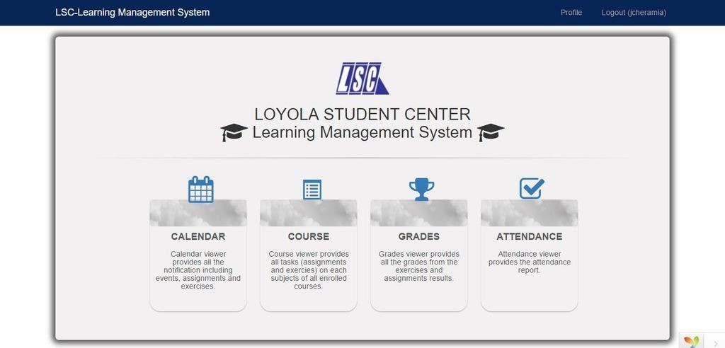

## **Login Page**



## **Backend**

## **Login Page**

****

## **Main Page**

****

## **PhpMyAdmin Database**

**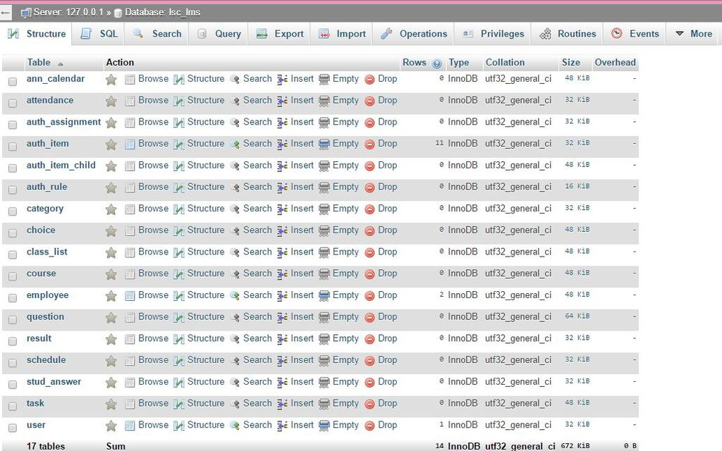**

## **Development and Testing, where applicable**

## **Description of the Prototype, where applicable**

The LSC Learning Management System is essentially an educational system that can be used in different devices. The features of the frontend include login, restricted the use of the LSC Learning Management System to enrolled students and faculty. The top part of the main page consists of a drop down navigation that includes the user profile button which redirect to user profile page and a logout button for signing out. The middle part of the main page consists of attendance button, lets the user view their attendances. Course button allows the user to access their online resources for a particular subject and take assignments. Calendar button is for checking announcements in the calendar. And grade button, allows the user to check his/her progress during the class.

The backend of the LSC-Learning Management System differs from the design in the frontend. The design helps the admin to adapt faster by making all complicated things look friendly. The backend includes a login to authorize if he/she is real. The main page for the backend differs from the design in the frontend where the admin will see the button such as course, grades, calendar, attendance on the left navigation bar that can be minimized. The top part of the main page is the same with the frontend design such as the availability to access their profile and to logout the LSC-Learning Management System.

## **Implementation Plan (Infrastructure/Deployment) where needed**

As the system will be implemented, it will be handed to the LSC admin and instructor. The student can access the system but with different Interface and work flow. On the Admin side, they will be the one to add, update and delete information.

## **Implementation Results, where applicable**

## **Conceptual design**

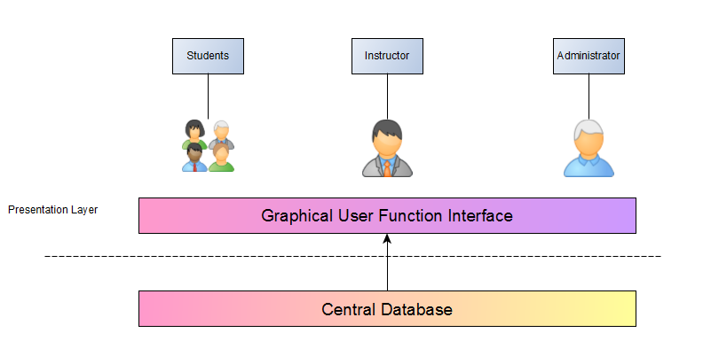

# Conclusions and Recommendations

In conclusion, the team was able to analyze the processes of the system and create the working prototype for the student(frontend) and (backend). Forms and models were generated that can be viewed and updated by the user. Features and designs are not yet completed and the team will work faster to be able to reach the scope of the system.

For the recommendation of creating a system, first, always plan and distribute the things that the team is going to do. Second, select a schedule for deadline and present it to the client many times before having a final presentation of the system for the changes needed. Third, since this system is not the only project that needs attention, manage time properly and always make a schedule so that everything would be fine. Lastly, do not start working on the project the week after the presentation.

# Appendices

## **Relevant Source Code**

* This method will render the index page





* This method is for the sign up of the user
* This line of code must be located inside the methods of SiteController.php if you want to use different layout for different pages.



* This method is for the login of the user



## **Evaluation Tool or Test Documents**

Project evaluation is important to analyze the system in order to have an overall understanding of the system, and to make decisions about whether or not to proceed in some of the requirements.

In evaluating the system, there will be an implementation test on the management and the students of LSC for them to be able to be familiar with the different functions of the system and for the team to be able to know if there are any changes that are needed.

## **Sample input/output/Reports**

## e.t%20studentproposed_zpsmtyoawld.png**Event Table – Student**

## 

## 

## **Event Table – Instructor**



## Event_Table_Propose_Admin_zpstqqjodl7.png**Event Table – Admin**

## Use%20Case%20FD%20Stud%201_zpssugsw0zk.png**Use Case Full Description – Student**



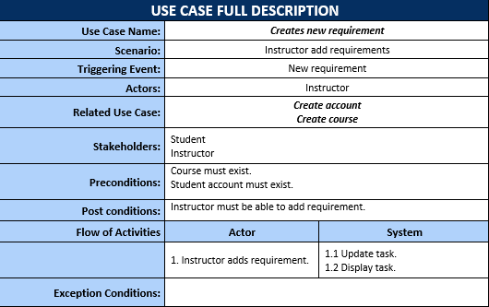

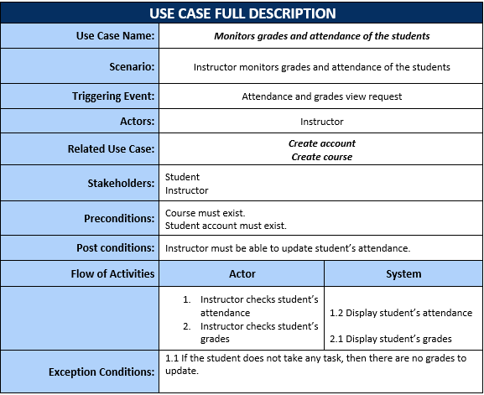

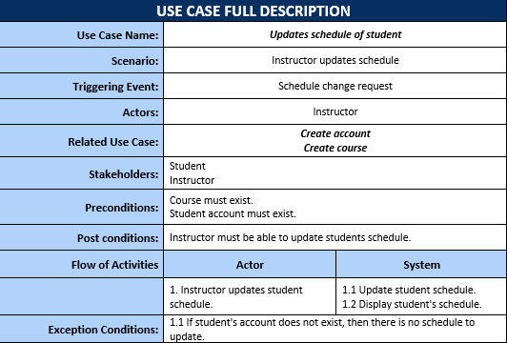

## Use%20Case%20FD%20Admin%201_zpsa2chaxyw.png**Use Case Full Description – Instructor**

## **Use Case Full Description – Admin**



## **Use Case Diagram – Student**

## UseCase-Diagram-Employee_zpspgfztrux.png**Use Case Diagram – Employee**

## **Activity Diagram – Student**

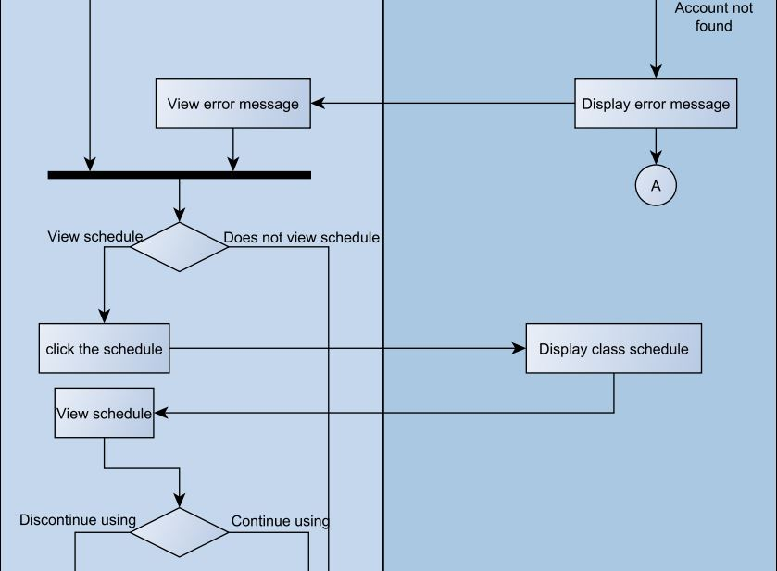

**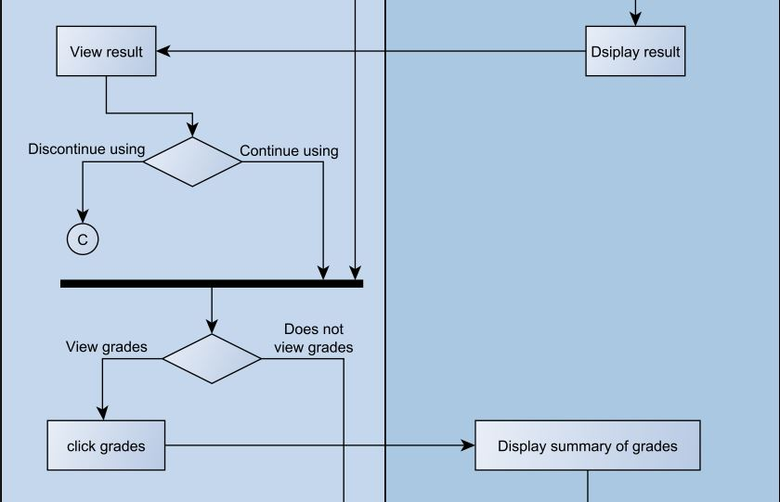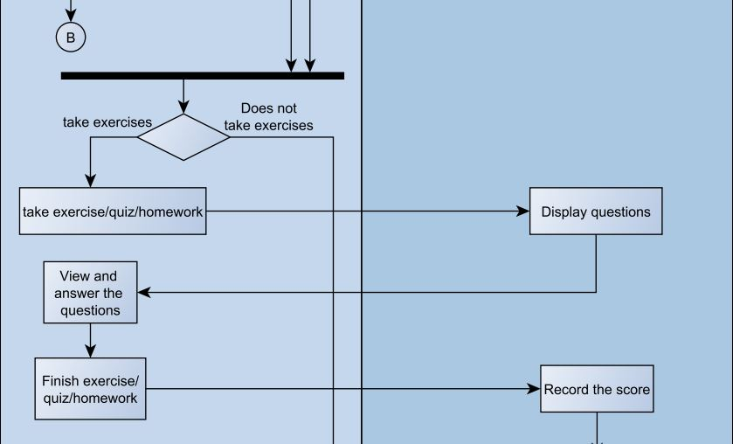**

**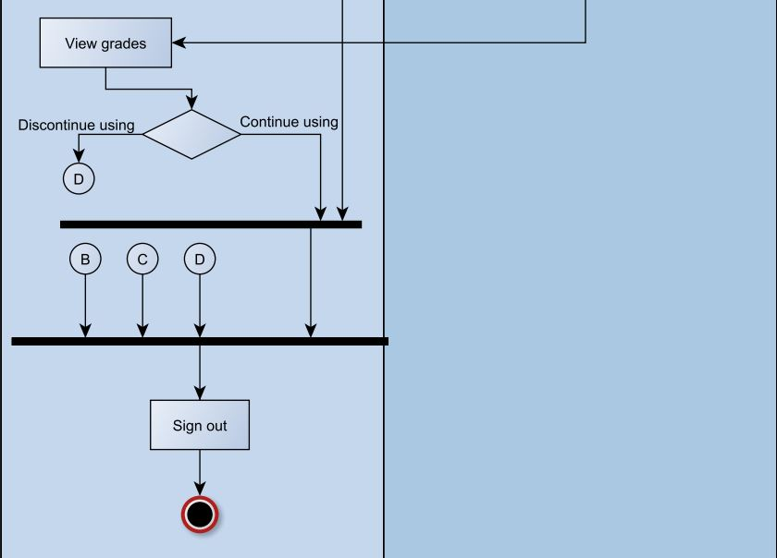**

## **Activity Diagram – Employee**

**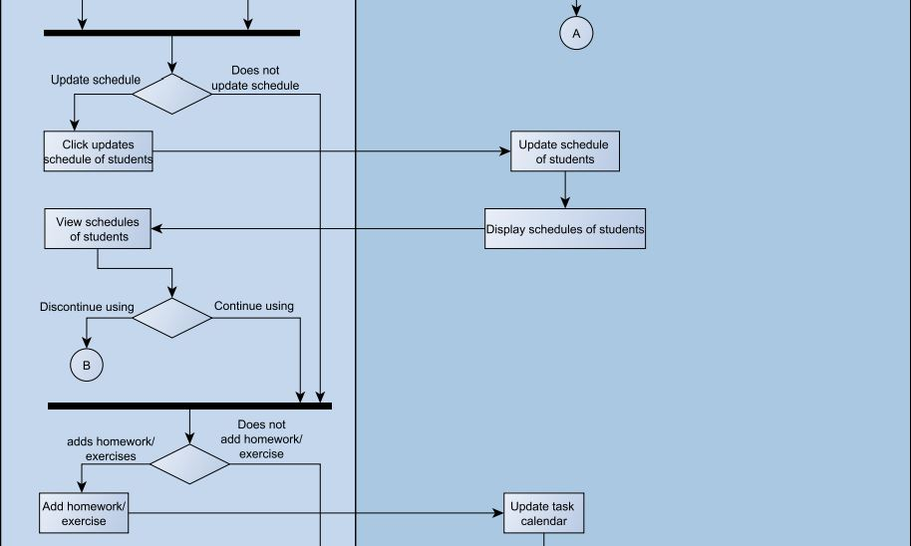**

**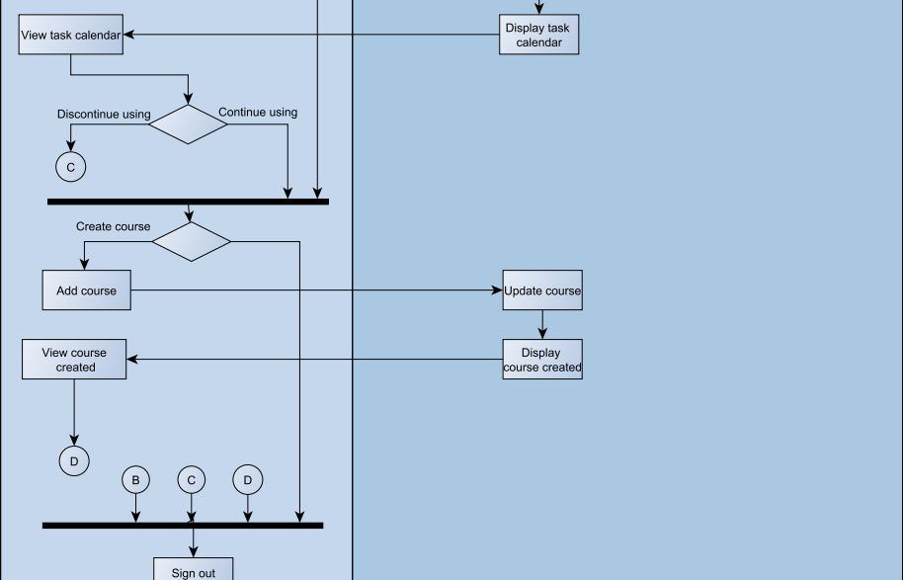**

## objectdiagram_zpsfesaxaph.png **Object Diagram**

## **Class Diagram**



## **Communication Diagram**



## StateMachineEmployee2_zpsyvrwt6eh.png

## StateMachineStudent_zpsxkzltkec.png **State Machine Diagram – Student**

## **State Machine Diagram – Employee**

## **Timing Diagram – Student**

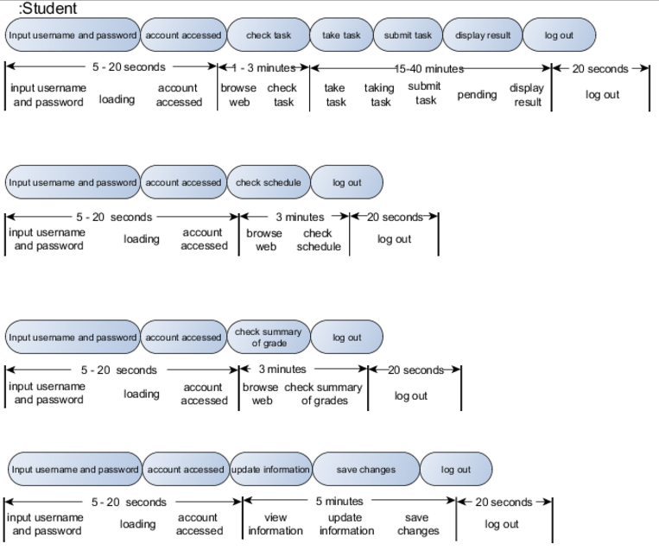

## **Timing Diagram – Instructor**



## **Timing Diagram – Admin**



## Capture **Package Diagram**

## Package_zpsddydugjx.png**Component Diagram**

## **Deployment Diagram**



## **Sequence Diagram**

  
  
  
  
  
  
  
  
  
  
  
  
  
  
  
  
  
  
  
  
  
  
  
  
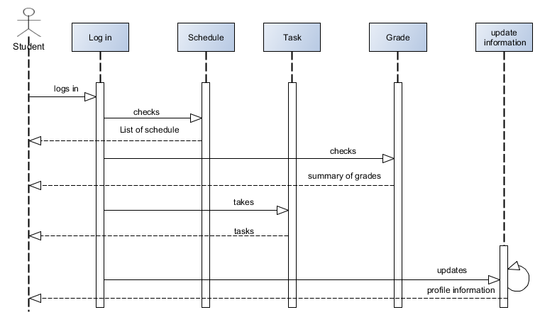

## **Composite Diagram**



## InteractionOverviewDiagram_zpsz7rkvsqh.png **Interaction Diagram**

## **Context Flow Diagram**

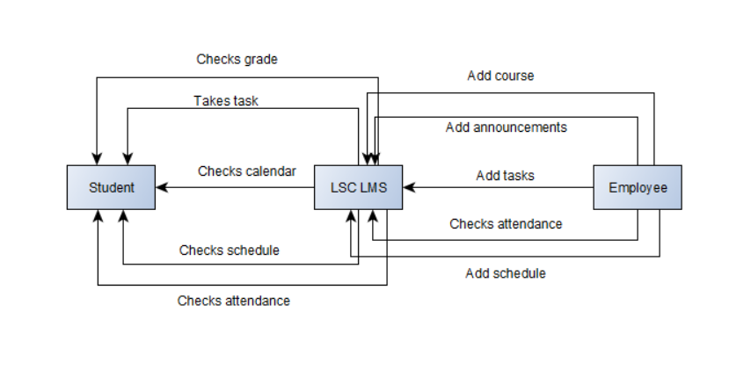

## **Data Flow Diagram – Level 0**

## 

## **Data Flow Diagram – Level 1 – Create Requirement**



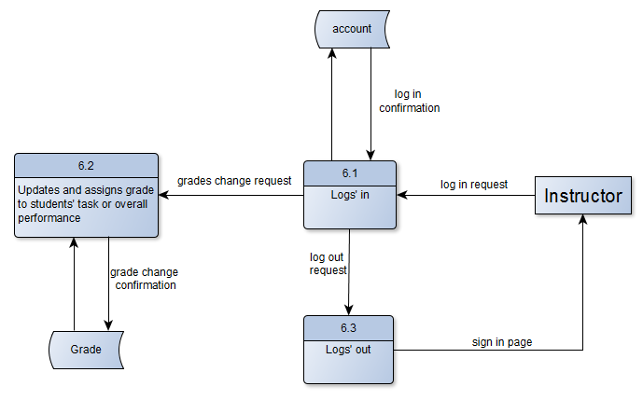

## **Data Flow Diagram – Level 1 – Update Student Profile**

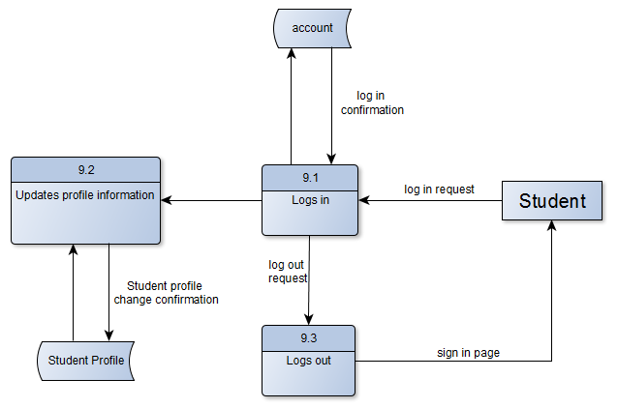

## **Entity Relationship Diagram**

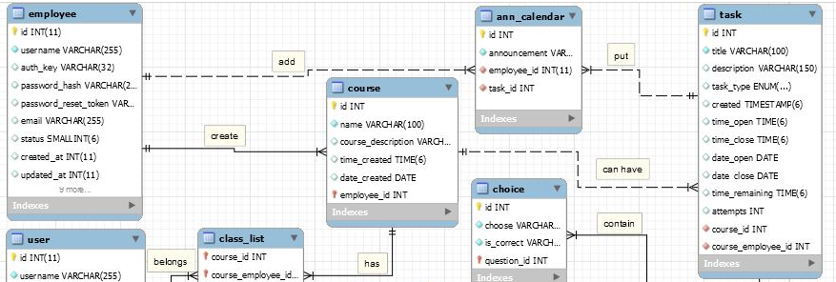

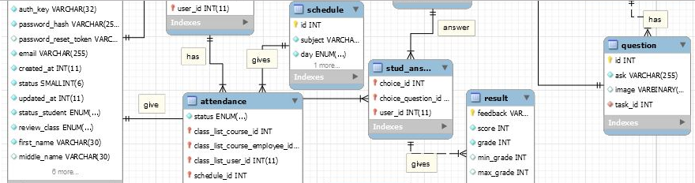

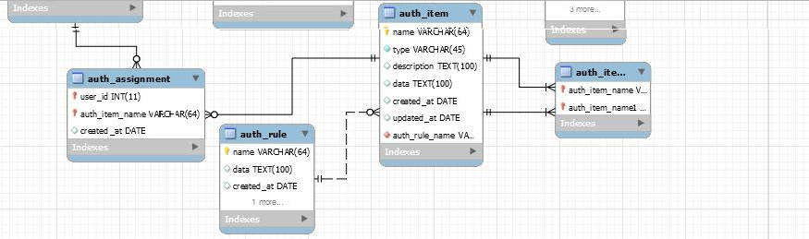

## **Data Dictionary**

## **Gantt Chart**





## C:\Users\Jana Marie Gardon\Desktop\WBSv32_zps8vo28xkp.pngC:\Users\Jana Marie Gardon\Desktop\WBSv11_zpszwthodvm.png **WBS**

## C:\Users\Jana Marie Gardon\Desktop\Activity%20Listv1_zpskkwiu20h.png **Activity List**

## **Project Vision and Scope**

## **Business Requirements**

Loyola Student Center is currently having a paper-based system where their assignments and exercises are presented in papers. The way they record the student’s attendance and scores are through papers as well. The management wanted something that a student can do online where they can give materials that the students can use as a practice at home but can only be accessed by students and by management only. Because of that, we come up with a possible solution of having a learning management system which will benefit both the students and the management that makes their work much faster and easier. Since students have their own account, the data will be more organized; most of their attendance, assignments and exercises will no longer be paper-based and even their schedule can be found in their account. Student will be informed, can review lessons and improve performance based on the results of their exercises. The instructor assesses the performance among learners, monitors their participation and creates tasks which is all through the use of technology. After their class, the students can still practice the lessons by taking the uploaded exercises.

## **Background**

Loyola Student Center (LSC) has many problems. One of those problems is their way of giving assignments and exercises using the paper-based system. The paper-based system can put an organization at a disadvantage in terms of profits because giving printed papers to each student can be expensive. Another problem is their way of announcements: the only way that the student can receive the announcement is through their lecturers. After analyzing the problems of LSC, our group came up with a system LSC Learning Management System (LSC LMS). Using LSC LMS can give many advantages such as giving assignments and exercises paperless. Cutting down the expenses in paper can be an advantage in terms of increase in profits. Another advantage of using the LSC LMS is that it can be used for announcements. Giving announcements ahead of time or immediately can make the students of LSC be prepared.

## **Business Opportunity**

A learning management system is efficient to use because it has been already proven and tested by some universities or colleges. Using LSC Learning Management System is a means of imparting knowledge to students by the use of technology. It is a combination of using both physical hardware and educational theories. Most people use technology and might as well use it for learning. There are lots of learning management system that provides different learning materials already but each has different lessons for students. Two of the existing LMS are Moodle and Learnanywhere where both created to provide learning to students through online which creates task, class curriculum and monitor their performance.

The LSC Learning Management System differs from other existing LMS because it is made only for LSC students where the learning materials are exclusive for them. The LSC-LMS consists of calendar where it does not only notify the student when there is an upcoming task but also shows the schedule of the student. Unlike other learning management system, the admin can directly check the attendance of the student on the attendance page while the student can view his or her attendance. Results on the activities are recorded and can be viewed by the students. All the contents are useful for the student and is a user-friendly system. Without LSC Learning Management System, the way they deliver tasks to students is still paper-based. The need to print out paper-based assessment will be reduced. With LMS they can access it anywhere as long as they are connected to the internet. Assessment papers are safe and can be reviewed anytime. Measuring the duration of time on answering those test. LSC Learning Management System allows the students to monitor their attendance. Since technology is widely used by people especially the students, it will be easier for student to take assignments online and to adjust easily. Students access it any time and it is not time consuming looking for a workplace.

## **Business Objective and Success Criteria**

Business objectives or goals are very significant in creating a project because it provides guidance and direction and it must be measurable and quantifiable given the limited amount of time. The following are the general and specific objectives or goals of LSC Learning Management System:

General Objective(s):

* To provide student an efficient way of learning by using the Learning Management System.
* To give the students of Loyola Student Center faster tracking of their performance to know what are the needed improvements.
* To provide Loyola Student Center easier administration.

Specific Objective(s):

* To provide the Loyola Student Center with LSC Learning Management System by upgrading their current processes and database for storing information.
* To provide the Loyola Student Center faster administration of records of tasks, grades and attendance of students.
* For the Loyola Student Center to announce updates faster
* For the students of LSC to have easier access on their progress online.

Success Criteria:

* The LSC Learning Management system meets its objectives.
* The Management of Loyola Student Center is satisfied with the result of the LSC LMS.
* The teachers of LSC can record student’s task, record and attendance.
* The students of LSC can monitor their performance and attendance and can take tasks online.

## **Customer or Market Needs**

Loyola Student Center’s customers and staffs will gain benefits when using the Learning Management System. Viewing of grades, viewing of the number of attendance, checking the availability of the lecturer, carrying less papers during review class, tracking the student’s progress, are some of the needs on the side of the customer. The needs on the side of the staff are immediate announcements such as availability of the lecturer, the organization of the student’s performance, paper less assignments and exercises. These needs enabled us to make a Learning Management System (LMS) for Loyola Student Center (LSC) so that the customers of LSC will give positive feedback about LSC’s way of processing and to the side of the staff by providing their best performance with less effort.

The LSC Learning Management System can provide the needs of both the customers and staff of LSC, such as the availability to view grades, attendance, and task of the customer and the immediate announcements of the staffs of LSC to their customers. Less papers are needed when doing and handing out assignments and exercises. The LSC Learning Management System can organize the performance of a student. These functionalities will be provided in the LMS. The LMS are incapable of doing such as sending messages to other customers or staff, posting unnecessary status such as current lectures, check the online users of LMS, and viewing other customers’ profiles and performance.

## **Business Risks**

Not all the improvements in business are always positive. Every improvement and every change have risks and it must be known in order for the organization to be prepared in case the negative effects of using the system happened.

LSC Learning Management System is an improvement that has some disadvantages. First, is user acceptance. Since this is an improved system, students, teachers and administrators might not adapt easily specially because it is more on technological usage. Some users specially the administrators or professors might have a hard time adjusting at first because they were acquainted and used to their existing processes of their system. In order to this for this problem to reduce, before the implementation of the LSC Learning Management System, teachers and administration must familiarize themselves with the usage of the system. There are manuals and they must be read carefully.

## **Vision of the Solution**

The LSC Learning Management System will provide easier administration of students' record and monitoring the students’ performance. The system will improve the way of giving tasks by taking it online. Also, easier announcements if there are any can be made to the students.

## **Vision Statement**

“As the Loyola Student Center moves toward the objective to be one of the center of educational excellence, LSC Learning Management System is supporting their goal by making their tutorial service the best tutorial center in the Philippines by providing LSC the Learning Management System that could give their customers the service that will help them to pass every examination that the customers will take”

## **Major Features**

The following are the major features of the Loyola Student Center’s Learning Management System (LSC LMS):

* Student can track his or her performance.
* Student can check his or her attendance.
* Student can take exercises willingly.
* Student can pass assignments through online.
* Student can check calendar for pending activities or announcements.

## **Assumptions and Dependencies**

While conceiving the project, the project members assumed that the LSC students already have an account to access the Learning Management System (LMS). Student will be able to take and submit assignments and exercises through online, view the calendar for pending assignments or announcements, and track his or her performance. The technologies that are needed for the LSC LMS to succeed are computers or laptops to create and modify the system. The wifi routers or the internet is the means to communicate to other members. And the framework “Yii2” to make the LSC LMS possible and the community of Yii2 for the 3rd vendor plugins. Consulting professors with specialization in database, systems, and security are also factors that can make the LSC Learning Management System success.

## **Scope and Limitations**

The LSC Learning Management System is a software application that provides variety of assessment. It is accessible by LSC management and student only. The system is only limited to the student of Loyola Student Center and it will not cover the enrollment of the student. Only enrolled students are eligible to have a LSC-LMS account. The materials used are exclusive for the LSC students. This system helps the admin to easily gives the student an assignment and exercises, check attendance and monitor the performance of the student. It aims to lessen the time and effort consumed on a paper-based system thus we created a learning management system. The students can view attendance, schedule and grades, and take assignments and exercises.

On our first project report with panel and client we present the project that also contains “Message” where the student can message their instructor. However, according to the client, it will not be useful for both client and admin. They do not require their students to contact the instructor when outside the premises.

## **Scope of Initial Release**

The project contains the profile of the student. When the student is already enrolled, he or she can already have an LMS account that was already created and will not allow the student to create the account anymore. The main focus of the project is to enable the student to take the assignment that calculates the duration of time from start to finish, and exercises that limits the time and attempts. The results from assignments and exercises can be viewed from another page. There is a calendar where the schedule is presented and so as the schedule of there are any task. When there is an upcoming event, it will show in the calendar and will notify the student. These features are updated by the admin, they are also the ones who add announcements, create assignments and exercises.

The student of LSC Learning Management System will greatly benefit from this project. Their lessons from a brick and mortar process can be reviewed in LSC Learning Management System through taking the exercises. It will lessen the time and effort they consume in preparing for some assessment papers and for looking for an available workplace to do the task because they can already access it online so even wherever they are as long as they are connected to the internet they can access the LMS and can take the tasks. This can be used as their practice at home and can improve the student’s performance.

## **Scope of Subsequent Release**

The team, has not discussed whether a feature will be envisioned over time or not.

## **Limitations and Exclusions**

At this time, the client is not expecting more features because everything that is needed has already agreed been agreed upon during the meeting.

## **Business Context**

The issue around the project is to make it secured well since the materials that will be used are exclusive for the LSC students. It requires the system to be well secured to prevent copying the contents and it should not be right-clickable to avoid to be print screened. The people who will use the system are Loyola Student Center’s instructor, admin and enrolled students for the review class. We provide a project equivalent to their paper-based system and the assumption is that the student must be able to take the activities and can view their grades and attendance. They must also be notified when there are upcoming events or activities, that is why we planned to add a calendar. The management prioritize the checking of attendance and creating task for the students*.*

## **Stakeholders Profiles**

The stakeholders of the LSC Learning Management System are the LSC itself and their customer. The value or benefits that the LSC Learning Management System include:

* Cost savings
* Immediate announcements
* Online submission of assignments
* Easier to check performance

|  |  |  |  |  |
| --- | --- | --- | --- | --- |
| **Stakeholder** | **Major Value** | **Attitudes** | **Major Interests** | **Constraints** |
| LSC | Cost savings | Increase in profit and efficiency | Online submission of assignments, online exercises | Internet dependent |
| Customer | Easily track performance | Easily identify their weakness | Provide result immediately | Internet dependent |

## **Project Priorities**

|  |  |  |  |
| --- | --- | --- | --- |
| **Dimension** | **Driver (state objective)** | **Constraint (state limits)** | **Degree of Freedom (state allowable range)** |
| Schedule | release 1.0 to be available by the end of October 2016  release 2.0 to be available by the second week of November 2016  release 3.0 to be available at by first week of December 2016 | Time constraint | 90 – 100% of the LSC Learning Management System’s functions must be done. |
| Features | The main function must properly working |  | 70-80% of high priority features must be included in release 3.0 |
| Quality | Provides the Loyola Student easier administration of student’s records online | Coding error or bugs are expected to occur at the 1.0 release | 90-95% of user acceptance tests must pass for release 2.0, 95-98% for release 3.0 |
| Staff |  | maximum team size is 3 developers + 4 testers | The 90-100% of the allowable time should be achieve for release 3.0 |
| Cost | The expanses must not exceed the maximum budget | Maximum budget | budget overrun up to 15% acceptable without executive review |

## **Operating Environment**

The system was built using Yii2 framework in both frontend and backend. Yi is an open source, object-oriented, component-based MVC PHP web application framework. Models and CRUD were generated. To connect to data, Apache Web Server and XAMPP Control Panel was used. All the data gathered are stored in a database powered by MySQL.

The LSC Learning Management System can be accessed within the Philippines as long as the user’s device is connected to the internet and the date will still be restored.

The system must be secured well that the user must not able to print or print screen the materials and is not right-clickable to prevent copying of their materials.

## **Statement of Work**

## **Introduction/Background**

Loyola Student Center (LSC) approved the project Learning Management System (LMS) to improve their current system in providing better services to their customers. The LMS main objective is to provide better service to their customer and to lessen their expenses by giving less papers to their customers. The LMS will have a user friendly interface for their customer and staff easily. The contents of the Learning Management System can be used to submit assignments, take exercises, view their schedule and calendar for announcements, and keep track with their performance and attendance. Using the Learning Management System can improve the LSC service such as handing out assignments online, providing the customer’s performance through the results, and informing the customers immediately through calendar. LSC group 2, the developers of LSC Learning Management System seeks to implement the system in the organization’s area for better evaluation of the LSC LMS. LSC can anticipate that their new system can make their work more efficient for both the employees and the customers.

## **Scope of Work**

The scope of work of the LSC Learning Management System includes all planning, execution and implementation for improving the existing process of the Loyola Student Center(LSC) on managing or administering students’ records such as their attendance, quizzes and their grades. The system will also help the student to monitor their performance based on their grades on their quizzes and exercises. This new system was based on the feedback and additional requirements that the LSC provided. Before designing the system, the development team must ensure that the database is all correct such as proper relationships, proper entities, and proper attributes. Specific deliverables and milestones will be listed in the Work Requirements and Schedules and Milestones sections of this SOW.

## **Period of Performance**

The period of performance for the LSC Learning Management System is within 6 months beginning in June 2016 through the third week of December 2016. All works must be scheduled to complete the system development within this timeframe. Any changes or extensions will be requested through the LSC for review and discussion.

## **Place of Performance**

The Loyola Student Center – Learning Management System developing members will perform a majority of its work at its own facility. They may schedule meetings with the LSC. All project gate reviews will be held at LSC’s facility and attended by the developing team. LSC will provide and arrange for meeting venues within its facility for all required meetings.

## **Work Requirements**

In developing LSC Learning Management System, the development team will be responsible for accomplishing tasks across the different stages of the system. The following is a list of all tasks which will result in the successful completion of this system:

Beginning:

* The team will create and will present the planning of the system including the Work Breakdown Structure (WBS)
* The team will present the project plan to LSC for review and approval

Design Phase:

* Consult with the LSC to know their requirements in the system
* Create the system’s design based on the gathered requirements
* Develop and improve the system’s design for LSC review and approval
* Present project status report at weekly meeting

Build Phase:

* The developing team will complete all the coding for approved system’s design
* The developing team will provide LSC with a detailed testing plan or manual
* The developing team will include all requirements provided by the LSC on improving their existing process
* The developing team will conduct testing before implementation of the system
* The developing team will resolve any coding and design issues identified in testing
* The developing team will compile testing report to present to LSC for review and approval
* Present weekly status at weekly meeting

Implementation Phase:

* The developing team will implement the new system of the LSC

Project Handoff/Closure:

- The developing team will provide LSC with all documentation in accordance with the approved project plan

- The developing team will present project closure report to LSC for review and approval

- The developing team will complete the project requirements checklist showing that all project tasks have been completed

- The developing team and the organization will have a meeting whenever changes are made.

## **Schedule/Milestones**

The list below consists of the initial milestones identified for the LSC Learning Management System:

**Planning**

* Meeting with the team June 13, 2016
* Layout Project Plan June 17, 2016

**Analysis**

* Gather information June 20, 2016
* Develop Event Table June 25, 2016
* Develop Use case full description July 15, 2016
* Develop UML Diagrams August 4, 2016
* Finalize wiki and One note August 26, 2016
* Develop GUI August 26, 2016
* Develop project functionality August 29, 2016
* Presentation of final project September 5, 2016
* Updating project requirements September 19, 2016
* Finalization of database October 12, 2016
* Updating GUI October 19, 2016
* Project Vision and Scope (initial release) October 14, 2016
* Statement of Work (initial release) October 14, 2016
* Updating system functionality November 2, 2016
* Finalize Activity List/WBS December 1, 2016
* Final presentation December 14, 2016

## **Acceptance Criteria**

The LSC admin will check if all their requirements were met to ensure the completeness of each stage then the acceptance deliverables will reside with head of LSC. After the completion of the project, the developing team will provide their report for review and approval. The manager of LSC will either sign off if they will advise what task must still be accomplished.

When the project is already completed, it will enter the closure stage. In this stage, the developing members will provide their project closure report and project task checklist to LSC management. Once the project has been accepted by the LSC it also means that he acknowledges acceptance of all project deliverables and that the developing team has met all assigned tasks. Any discrepancies related to the completion of project or disagreement among LSC and the developing team will be referred to both organizations' contracting offices for review and discussion.

## **Other Requirements**

Security is important in the Loyola Student Center specially in their materials for exercises or assignments which restricts non-LSC student to have an access. No print screening, copy pasting or printing of their materials are one of the requirements in security of the LSC in LSC LMS.

## **Software Requirement Specification**

## **Introduction**

## **Purpose**

The purpose of software requirement specification (SRS) is to provide a full description of the LSC Learning Management System functionalities, the stakeholders, and the requirements to implement the Learning Management System (LMS) so that the Loyola Student Center (LSC), our client, can verify all the necessary content that is included and the team can have the complete understanding in the development of the project.

The following are the objectives of the SRS:

* To serve as a basis for improvement of the finished system
* To provide a realistic basis for estimating costs and schedules
* To provide a basis for developing the software design
* To establish the basis for agreement between the client and the system developers

## **Document Conventions**

This document is set in Microsoft Word 2016, with a font “Arial” and font size of 11. Each part of the document is written as header 1 and under each part are in header 2; both are in tube property.

*Acronym and Abbreviations:*

1. LMS: Learning Management System
2. SRS: Software Requirement Specification
3. LSC: Loyola Student Center

## **Intended Audience and Reading Suggestions**

The intended readers of the SRS document are the following:

* Developers - Developers are those who manage the entire document and system. They may use this document to implement the functionalities and to ensure to be in the right track while doing the system. When there are changes that are needed, they can look through this document for guidance.
* Project Managers - The project manager may use this document to manage the entire LSC LMS such as changes in requirements, resources etc.
* Testers - The testers may use this document to have knowledge on how and what the LMS is capable of doing. They will test the developed system with the given cases and estimate the performance of the system.
* Writers of the documents - The document writers may use this document to know the proper flow in creating a document and they are the one who are going to prepare the user manuals and other necessary documents of the system
* Users - Users are those who will be needing this system. The users may use this document to gain knowledge in the different functions and interfaces of the LSC Learning Management System. They may also use this document to know the difference between LSC Learning Management System to other existing learning management system. This can be used for easy access and familiarization to the system since this system will be used mostly by them. Consequently, they can also examine the software consequently and can check in this document the suitable requirements and whether developers had implemented all the system’s requirements.

The remaining information in this document describes the functional requirements of the system.

## **Scope**

The LSC Learning Management System is a software application that aims to improve the current system of LSC in giving tasks, announcing important announcements and tracking of students. It will not only benefit the management of the LSC but also the students who enrolled in their classes.  
 For the students, they will be able to take tasks online, to track their performance based on the results of their tasks, to easily know if there are tasks to do through the calendar and to also track their attendance. For the tutor, they will be able to create courses in classes and add student to that course, to add tasks (in task, the tutor can give on how many attempts the student can have and can also put time limits) and to track the attendance of students.   
 So, using this LSC Learning Management System, can provide better service and chance for the students of Loyola Student Center in passing their targeted school or college and to pass their exams. For the goal of LSC Learning Management System, refer to the “Project Vision and Scope Document”.

## **References**

The following are the references for the documents of LSC-LMS:

* Minimum Requirements for Web Based Applications. (2016, February 26). Retrieved October 22, 2016, from https://support.skyward.com/DeptDocs/Corporate/IT Services/Public Website/Technical Information/Workstation Requirements/Web Based Workstation Requirements.pdf
* Project – LSC Group 2 – 101. Retrieved from http://projects2.apc.edu.ph/wiki/index.php/Project\_-\_LSC\_Group\_2\_-101
* BS Education Free CSS Template. (2015, December 11). Retrieved from <http://www.free-css.com/free-css-templates/page193/bs-education>

## **Overall Description**

## **Product Perspective**

LSC Learning Management System aims to improve the existing system of the LSC that enable the student to have access on their class curriculum like exercises and assignments online and enables the admin to save students class information which makes the data more organized. This software can help integrate the system then later be released and accessed. It is used to replace their paper-based existing system and some of functionalities of the LSC-LMS may be similar to other existing LMS, however this system is made only for the LSC student, instructor and admin that has specific requirements requested by the client.



## **Product Functions**

The Loyola Student Center Learning Management System is provided for the LSC Management and for the students. Before the student or employee could do the following, he or she must have an account first. The following are the functions of LSC LMS:

* Employee:
  + Can create a course for review class for the students
  + Can record the student’s attendance during the class
  + Can create and assign task such as assignments, quizzes and exercise
  + Can give announcements through the calendar
  + Can update the student’s grades
* Student:
  + Can access the review class
  + Can view their attendance
  + Can take tasks
  + Can see the announcements through calendar
  + Can keep track of their grades

## **User Classes and Characteristics**

There are three kinds of users that are expected to use the LSC-Learning Management System. Each kind of user has their own roles and should perform different operations within the system.

* Administrative staff (or System administrator), users with LSC Learning Management System administrator knowledge
* Tutors or Lecturers, users with LSC LMS usage knowledge
* Students, users with LSC LMS usage knowledge

The administrator must be familiar with the web applications and shall configure the environment for the rest of the users who must have the LSC LMS database knowledge or information so they can use the LSC LMS without problems.

Tutors or lecturers should have at least basic knowledge in managing computer devices. The professors or lecturers will be the one who will create courses and will manage the students’ records in class such as checking of the attendance and who will give assignments, exercises or quizzes to classes.

Students should have at least basic knowledge on what the LMS can do. The students can use the LMS to view their records and take tasks such as assignments, quiz, or exercise.

## **Operating Environment**

OE\_1: The LSC LMS shall operate with any web browser and It is recommended that it is in the latest version.  
OE\_2: The LSC LMS shall operate on Windows, iOS, Linux and Android operating system  
OE\_3: The LSC LMS can be accessed by any LSC students or personnel.

OE\_4: The LSC LMS backend can only be accessed inside the LSC premises only.  
OE\_5: Minimum hardware requirements: Dual Core 1.6GHz of faster. RAM: 1 gigabyte (GB) (32-bit) or 2 GB (64-bit).

## **Design and Implementation Constraints**

The LSC students and admin can use this system because the information must be kept within LSC-LMS users only. While the students are taking the exam, right click is invalid to avoid printing the questions.

DaIC\_1: The LSC Learning Management System design’s and functionalities shall adapt or modify the process of the current system of LSC.  
DaIC\_2: The LSC Learning Management System must follow the given requirements of the client.  
DaIC\_3: The LSC Learning Management System must perform validation checks in user’s input  
DaIC\_4: The materials that will be used online should not be printable or not right clickable for the students to be able to not to share it online or with anyone.  
DaIC\_5: The system uses PhpmyAdmin MySQL for the database.  
DaIC\_6: The system uses Yii2 (advance template) and Admin LTE (theme in backend) to build the system.  
DaIC\_7: PHP, CSS and JavaScript are being combined in creating the system interfaces.

## **User Documentation**

Together with the LSC LMS, for the user to be able to understand how it work and what are the usage of the system, user manuals will be written and provided under the client’s perspective and understanding. The readers of manuals are assumed to be nontechnical readers thus, every terminology is easy to understand. The user manual includes step-by-step procedures.

## **Assumptions and Dependencies**

A\_1: Once the student is enrolled he or she can already have a LSC account. There’s no need for the student/guardian to sign-up on their own.

A\_2: They can take exercises and assignments, and can view the results and grades.

A\_3: Students can monitor their attendance as the instructor will check the attendance using LSC Learning Management System.

A\_4: The student can be notified when there are upcoming events and tasks in the calendar page.

A\_5: Since it is an account, there is a profile page that contains personal information of the student.

A\_6: The instructor can add tasks and events on each of the student’s account.

A\_7: The admin can update the information in the system.

A\_8: The admin/instructor can have their own account on the backend side.

D\_1: A student must enroll first to have an account.

D\_2: It must be connected to the internet to access it.

D\_3: A browser is needed to access and view the system.

D\_4: Management efficiency to meet the client’s satisfaction.

## **External Interface Requirements**

## **User Interfaces**

Here are some of the screenshots of the interfaces of LSC LMS.

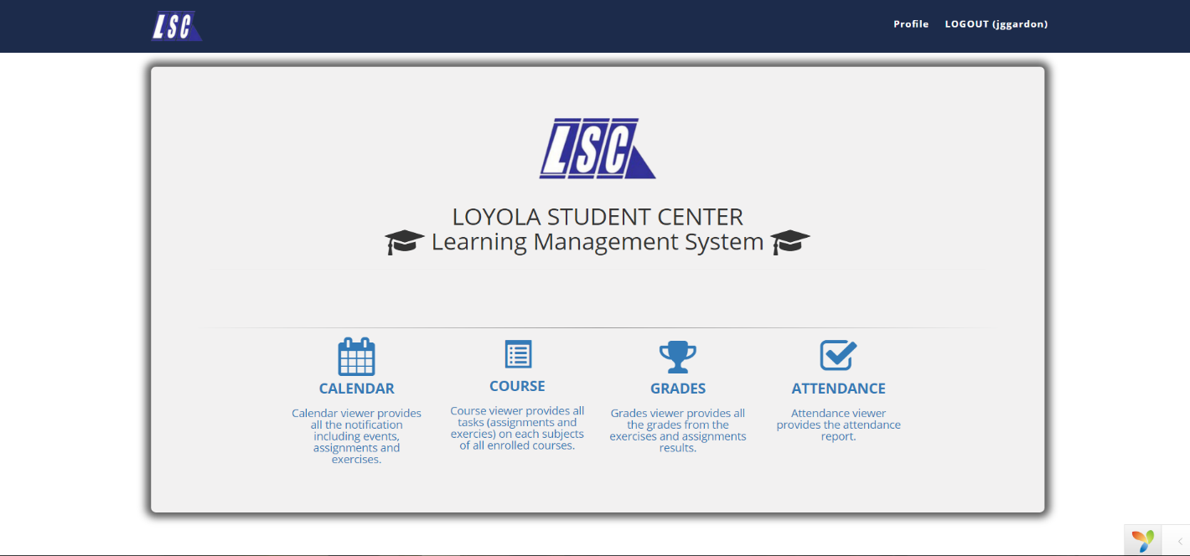**Frontend**

Figure 1. Main Page

This is the sample main page for the student in frontend. There are four sections: calendar, course, grades and attendance. In calendar, the student can check the schedule of their classes and also if there are tasks that they need to do. The calendar will serve as the reminder for the students. Next is the course. In this section, the student can see their courses that their tutor created. Then for the grade section, the student can see grades of their different tasks. Lastly the attendance. The student can see their attendance in a specific course. This section will let them know how many absences they had in the past.

**Backend**

  
Figure 2. Login Page

This is the login page for the backend side. The backend side is only accessible within the LSC premises only.

## **Hardware Interfaces**

For client side:  
**Hardware**: Minimum System Requirement  
**Processor**: at least 1.3 GHz processor or faster  
**Memory**: 128 MB RAM (256 MB recommended)  
**Disk Space**: 80GB or above  
**Screen resolution**: at least 800 x 600 colors or above

For web server side:

|  |  |  |  |  |
| --- | --- | --- | --- | --- |
| **Item** | **Web server (minimum)** | **Web server (recommended)** | **Combined Web & Database Server (minimum)** | **Combined Web & Database Server (recommended)** |
| **Processor** | 1.6 Ghz | 2 x 1.6 GHz CPU | 2 x 1.6 GHz CPU | 4 x 1.6 GHz CPU |
| **RAM** | 1.75 GB RAM | 3.5 GB RAM | 3.5 GB RAM | 7 GB RAM |
| **HDD** | 1x 40 GB of free space or more is recommended. 1x 40 GB of free space or more is recommended for the software. | | | |

## **Software Interfaces**

The needed software interfaces to use the LSC-LMS are the following:

* Windows, Linux, iOS and Android operating system environment
* The graphical user interfaces and other parts of LSC LMS software are to be done using the Yii2 advanced framework. It uses HTML, CSS, PHP 5.4, Bootstrap, JQuery etc.
* The output of the software will need a browser (e.g. Chrome, Internet Explorer, Firefox) for viewing it.
* The database in use is MySQL
* The LSC LMS is dependent to the LSC Enrollment System, so it must be integrated with the Enrollment System.

## **Communications Interfaces**

* Internet connection and a browser are required.
* Client on Internet will be using HTTP/HTTPS protocol

## **System Features**

## **Creating Course**

## **Description and Priority**

The admin or lecturer provides the students courses to access the learning materials of a review class. The priority of creating a course is High.

## **Stimulus/Response Sequences**

* **Stimulus**: The admin/lecturer creates new course
* **Response**: The added course will be inserted in the database and the page will display

## **Functional Requirements**

**REQ-1:** The admin/lecturer should have an account  
**REQ-2:** The admin/lecturer should be connected to the internet

## **Adding Tasks**

## **Description and Priority**

The admin/lecturer adds tasks such as assignments and exercises for the student. The priority of adding a task is Medium.

## **Stimulus/Response Sequences**

* **Stimulus**: The admin/lecturer access the course link
* **Response**: The course page is displayed
* **Stimulus:** The admin/lecturer adds a task
* **Response**: The added course will be inserted in the database and the task page will display

## **Functional Requirements**

**REQ-1:** The admin/lecturer should have an account

**REQ-2:** There should be an existing course

## **Making Announcement in Calendar**

## **Description and Priority**

The admin/lecturer can make announcement in the calendar. The priority of making an announcement in calendar is Low.

## **Stimulus/Response Sequences**

* **Stimulus:** The admin/lecturer access calendar link
* **Response:** The calendar page will display
* **Stimulus:** The admin/lecturer will select a date and add an announcement
* **Response:** The announcement will be displayed inside the selected date

## **Functional Requirements**

**REQ-1:** The admin/lecturer should have an account

## **Listing Attendance**

## **Description and Priority**

The admin/lecturer can list the attendances of the students whether he or she is present during the class. The priority of listing the attendance of the student is High.

## **Stimulus/Responses Sequences**

* **Stimulus:** The admin/lecturer access the attendance link
* **Response:** The attendance page will display
* **Stimulus:** The admin/lecturer select’s a student and updates his or her status duringthe class
* **Response:** The updated status of the student will be saved in a database to keep track of the student’s attendance

## **Functional Requirements**

**REQ-1:** The admin/lecturer should have an account

**REQ-2:** The admin/lecturer should be enrolled in the review class

**REQ-3:** The student should have an account

**REQ-4:** The student should be enrolled in the review class of the

Lecturer

## **Other Nonfunctional Requirements**

## **Performance Requirements**

* The response of the system depends on whether the internet connection is slow or fast.
* The system shall display a confirmation message or result to users right after the user submits his or her answers in the exercises and assignments.
* The calendar will notify when there is an upcoming event or task to do.
* The system should generate policy with an accuracy of 99%
* The time and date when the user pass the task or the instructor adds task and event, and delete task, depends on the time and date on the user’s device.

## **Safety Requirements**

The LSC LMS must only be authorized by LSC students, admin and instructors only. All the information is restricted and must not be accessed by non-LSC students and employees. All the exercises and assignments must be secured well. During taking the task, the user can’t right click the page to avoid printing the questions. There is a consistency since the system is connected to only one server.

## **Security Requirements**

The security requirement of the LSC are, only the approved students of the LSC can access the LSC-LMS and the task that will be given by LSC such as assignments and exercises should not be printed or saved in any devices. The team’s solution for both security requirements are, the students email and password will be created when the administration of the LSC approved of his or her account. The information is secured and accessed only between LSC students and employees since the students can only have an account when he/she is already enrolled. Moreover, there will be no access to LMS once the student is already unenrolled. Regarding the task security, the team came up with the solution of “not right clickable” making the task unprintable and not downloadable.

## **Software Quality Attributes**

## **Security**

* The LSC LMS will run inside a firewall for security.
* The LSC LMS will support different roles for users such as tutors, students and system administrator. The user logged in with given role should only be allowed with that role (e.g. Student will only be allowed to see his or her grades not to change it.).
* In HTTPS, it enables access to web application to secure access of the confidential data such as the student’s data. The Administrator of LSC LMS will have full database administration control and tutors may have access to copy of some parts of database for editing purposes.
* The LSC materials for quizzes shall not be printed

## **Reliability**

* The LSC LMS images should be clear and understandable.
* The system shall not be down for more than three times a year.

## **Scalability**

* The LSC LMS must be scalable to a large number of users since courses will have hundreds of students.

## **Availability**

* The LSC LMS must be available 24/7 so that student and tutors can use it any time

## **Responsiveness**

* Less responsive time must be there so that the users will feel good while using the system.

## **Business Rules**

LSC Learning Management System will be used by the LSC students, instructor and admin. The student will automatically have a LSC Learning Management System account once he/she is already enrolled. The admin is responsible for the update of the personal information of the student while the instructor adds course, subjects, tasks, events and check attendance to each of the student’s account. The following are the step by step business rule of the LSC Learning Management System:

* + - * It is assumed that student and tutor has an account already when logging in to the system.
      * The tutor will create a course and add students to it.
      * The tutor will check attendance
      * The tutor will create task such as quizzes, homework or exercise
      * The student will be notified that there are tasks that are needed to be done
      * The student can now take the tasks given by the tutor, then after taking the task there will be a result page. In a result page, student can see their grades, minimum and maximum grades.
      * The student can view their attendance and to check to know for example their number of absences.

## **Other Requirements**

## **Appendix A: Glossary**

**Backend** - Denoting a subordinate processor or program, not directly accessed by the user, which performs a specialized function on behalf of a main processor or software system.

**Constraint** – Limitation or restriction

**Data** - A collection of facts from which conclusions may be drawn.

**Diagram** - A drawing intended to explain how something works; a drawing showing the relation between the parts.

**Frontend** - directly accessed by the user and allowing access to further devices, programs, or databases.

**Hardware** - the machines, wiring, and other physical components of a computer or other electronic system.

**Interface** - a visual way of interacting with a computer using items such as windows, icons, and menus, used by most modern operating systems.

**Operating system** - the software that supports a computer's basic functions, such as scheduling tasks, executing applications, and controlling peripherals.

**Software** - the programs and other operating information used by a computer.

**System** - a set of connected things or parts forming a complex whole, in particular.

**Tracking** - the maintenance of a constant difference in frequency between two or more connected circuits or components.

## **Appendix B: Analysis Models**

The Entity Relationship Diagram (ERD) was analyzed upon the requirements of the LSC.

*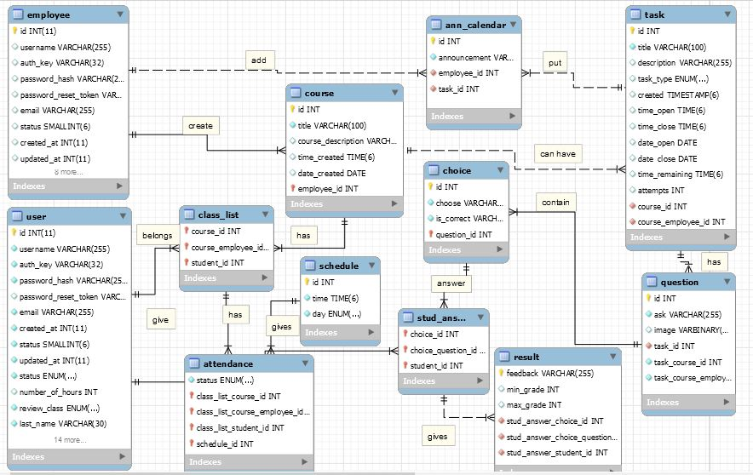*

## **Change Management Plan**

## **Introduction**

The Change Management Plan is created for LSC Learning Management System to ensure that the project is on the right track and knowing what should and should not be included in the project to guarantee the project content is within the scope. Managing the project is keeping up with its changes, defining changes and knowing the purpose and role of the change control board. It is assumed that all the stakeholders will submit or request changes to the LSC-LMS project in line with this Change Management Plan and changes will apply to all request and submissions based on the process detailed herein.

## **Change Management Approach**

The Change Management approach for the LSC Learning Management System Project will ensure that all proposed changes are defined, reviewed, and agreed upon so they can be properly implemented and communicated to all stakeholders. This approach will also ensure that only changes within the scope of this project are approved and implemented.

The Change Management approach is not to be confused with the Change Management Process which will be detailed later in this plan. The Change Management approach consists of three areas:

* Ensure changes are within scope and beneficial to the project.
* Determine how the change will be implemented
* Manage the change as it is implemented

The Change Management process has been designed to make sure this approach is followed for all changes. By using this approach methodology, the LSC Learning Management System Project Team will prevent unnecessary change from occurring and focus its resources only on beneficial changes within the project scope.

## **Definitions of Change**

There are several types of changes which may be requested and considered for the LSC Learning Management System Project. Depending on the extent and type of proposed changes, changes project documentation and the communication of these changes will be required to include any approved changes into the project plan and ensure all stakeholders are notified. Types of changes include:

* Scheduling Changes: changes which will impact the approved project schedule. These changes may require fast tracking, crashing, or re-baselining the schedule depending on the significance of the impact.
* Budget Changes: changes which will impact the approved project budget. These changes may require requesting additional funding, releasing funding which would no longer be required, or adding to project or management reserves. May require changes to the cost baseline.
* Scope Changes: changes which are necessary and impact the project’s scope which may be the result of unforeseen requirements which were not initially planned for. These changes may also impact budget and schedule. These changes may require revision to WBS, project scope statement, and other project documentation as necessary.

The project manager must ensure that any approved changes are communicated to the project stakeholders. Additionally, as changes are approved, the project manager must ensure that the changes are captured in the project documentation where necessary. These document updates must then be communicated to the project team and stakeholders as well.

## **Change Control Board**

The Change Control Board (CCB) is the approval authority for all proposed change requests pertaining to the LSC Learning Management System Project. The purpose of the CCB is to review all change requests, determine their impact on the project risk, scope, cost, and schedule, and to approve or deny each change request. The following chart provides a list of the CCB members for the LSC Learning Management System Project:

|  |  |  |
| --- | --- | --- |
| **Name** | **Position** | **CCB Role** |
| J. Limos | LSC LMS Project Sponsor | CCB Chair |
| J. Gardon | LSC LMS Project Manager | CCB Member |
| R. Gardon | LSC LMS Project Technical Lead | CCB Co-Chair |

As change requests are submitted to the LSC Learning Management System Project Manager by the project team/stakeholders, the Project Manager will log the requests in the change log and the CCB will convene every other Friday to review all change requests. For a change request to be approved, all CCB members must vote in favor. In the event more information is needed for a particular change request, the request will be deferred and sent back to the requestor for more information or clarification. If a change is deemed critical, an ad hoc CCB meeting can be called in order to review the change prior to the next scheduled bi-weekly CCB meeting.

## **Roles and Responsibilities**

The following are the roles and responsibilities for all change management efforts related to the LSC Learning Management System Project:

*Project Sponsor:*

* Approve all changes to budget/funding allocations
* Approve all changes to schedule baseline
* Approve any changes in project scope
* Chair the CCB

*Project Manager:*

* Receive and log all change requests from project stakeholders
* Conduct preliminary risk, cost, schedule, scope analysis of change prior to CCB
* Seek clarification from change requestors on any open issues or concerns
* Make documentation revisions/edits as necessary for all approved changes
* Participate on CCB

*Project Team/Stakeholders:*

* Submit all change requests on standard organizational change request forms
* Provide all applicable information and detail on change request forms
* Be prepared to address questions regarding any submitted change requests
* Provide feedback as necessary on impact of proposed changes

## **Change Control Process**

The Change Control Process for the LSC Learning Management System Project will follow the organizational standard change process for all projects. The project manager has overall responsibility for executing the change management process for each change request.

1. Identify the need for a change (Stakeholders) – Change requestor will submit a completed change request form to the project manager.
2. Log change in the change request register (Project Manager) – The project manager will keep a log of all submitted change requests throughout the project’s lifecycle.
3. Evaluate the change (Project Manager, Team, Requestor) – The project manager will conduct a preliminary analysis on the impact of the change to risk, cost, schedule, and scope and seek clarification from team members and the change requestor.
4. Submit change request to CCB (Project Manager) – The project manager will submit the change request, as well as the preliminary analysis, to the CCB for review.
5. Obtain Decision on change request (CCB) – The CCB will discuss the proposed change and decide whether or not it will be approved based on all submitted information.
6. Implement change (Project Manager) – If a change is approved by the CCB, the project manager will update and re-baseline project documentation as necessary.

## **Quality Plan**

## **Introduction**

This document, together with other referenced documents, defines the responsibilities and procedures to be adopted to ensure that the data and information produced as part of LSC Learning Management System are reliable, fit for purpose and consistent with documented objectives and deliverables. It summarizes the system of internal management that governs the decisions and instructions concerning project quality assurance.

## **Project Contractual Information**

|  |  |
| --- | --- |
| Project: | LSC Learning Management System |
| Programme Co-ordinator: | Ms. Joan Limos  (LSC Admin) |
| Principal Investigators(s): | LSC Enrollment System Team  Ms. Roselle Wednesday Gardon  (Project Adviser) |

## **Scope of Work and Quality Objectives**

|  |  |
| --- | --- |
| Scope of work:  Quality Objectives: | The coverage of LSC Learning Management System is:   * Instructor can create and update course in classes. * Instructor can add tasks such as quiz, exam or exercise in classes. * Instructor can add announcements on calendar. * Student can take tasks. * Student can view their grades and attendance.   The LSC Learning Management system is only limited to the students of LSC. This system will not cover the enrolment of the student; therefore, it is assumed that the student is already enrolled. Students who are enrolled will automatically have an account.  The following are the quality objectives of the LSC LMS:   * To provide the Loyola Student Center with a system for the learning management system and a database for their requirements. * For faster administration of records of the task, grades and attendance of students in classes. * For the administrator to announce updates faster and those announcements can be seen right away by the students in each class * For the students of Loyola Student Center to have easier access on their progress online. |

## **Project Organization**

|  |  |
| --- | --- |
| Project Manager(s): | Jana Marie Gavarra Gardon |
| Task Manager(s): | Ms. Roselle Wednesday Gardon  (Project Adviser) |
| Quality Assurance: | Jana Marie Gavarra Gardon  (Project Manager) |
|  |  |
| Other Team Members: | Johanna Marisse Credito Heramia  Jose Lorenzo Gonzales Tadeo |
|  |  |
| Technical Reviews: | Mr. Francis Uñalivia (Database consultant)  Mr. Jojo Castillo (Project consultant)  Mr. Justin Pineda (System security consultant)  Mr. Allan Cotecson (Project consultant) |

## Capture**Project Duration and Scheduling**

|  |  |
| --- | --- |
| Start Date: | June 13, 2016 |
| Completion Date: | December 14, 2016 |
| Scheduling of Activities: | *.* |

## **Deliverables**

Deliverables specified for the project include:

1. An acceptable Quality Plan
2. An acceptable Change Management Plan (*Appendix YY*)
3. An acceptable Software Requirement Specification
4. An acceptable Scope of Work
5. An acceptable Project Vision and Scope
6. Progress Reports
7. User Manual
8. Final Paper

## **Review of Quality Plan**

The Quality Plan will be reviewed every consortium meeting at least once a month to keep the information produced as reliable, fit for the purpose, consistent with the objectives and deliverables and within the project scope.

## **Document and Record Control**

Project documents, records and data will be controlled and stored in GitHub ([www.github.com](http://www.github.com)), which is a web-based repository hosting service that offers all the distributed version control and Projects Wiki ([www.projects2.apc.edu.ph/wiki](http://www.projects2.apc.edu.ph/wiki)) by Jana Gardon, Johanna Heramia and Renzo Tadeo. It will be clearly labelled and made available for consultation by all members of the project team.

The Quality Plan, Project Vision and Scope, Scope of Work, Software Requirement Specification and Change Management Plan will be issued to all members the team.

Project Progress Report will be issued to the following:

* Project Adviser
* Professor

## **Document Procedures**

* Change Management Plan – this is used to track changes done while developing the system, define changes for managing the system, and to familiarize more on the project scope.

<http://projects2.apc.edu.ph/wiki/index.php/Project_-_LSC_Group_2_-101#Change_Management_Plan>

* Software Requirement Specification – a document consists of the hardware and software used, functionalities, interfaces and system features.

<http://projects2.apc.edu.ph/wiki/index.php/Project_-_LSC_Group_2_->101#Software\_Requirements\_Specification

## **Users Guide**

## **Process/Data/Information Flow**

*Frontend:*

* The student will sign-in to the system.
* The main screen will appear which contains the calendar, grades, attendance and course
* When the student clicks the calendar, all the event that was added by the instructor will appear on the class calendar of the student. The event may be the task to be done and its submission, or the announcements.
* When the student clicks the grades, all grades from the tasks will appear including the summary, depending on the instructors input.
* When the student clicks the attendance, the attendance report of the student alone will appear.
* When the student clicks the course, all the course the student is currently enrolled will appear and under each course many subjects and when the student checks on one of the subjects, he/she may know whether there are tasks that need to be done.
* When the student wants to end the session, he/she may click the log out button.

*Backend:*

* The admin or instructor may sign-up for an account
* The admin or instructor may log-in when they already have an existing account
* The admin may update the content of the system such as the student’s profile information.
* The instructor may add events in the calendar, edit it or delete it.
* The instructor may add the students in their class curriculum, and add tasks such as assignments and exercises.
* The instructor may check the student’s attendance in LMS.
* The instructor adds the grades of the student.
* The log out button to end the session.

## **Test Results**

## **Sample Generated Outputs**

## **Pictures showcasing the data gathering, investigation done**

## Vitae_zpsuksf1c7r.png**One-Page Curriculum**

